INTERROGATION REPORT

NAME:-Anurag @ AnuradhaChoudhary @ Madam Minj @ Lady Don D/o Sh. RamdevMahala, R/o Opposite Modi School, Town and PS LaxmangarhDistt. Sikar, Rajasthan
Date Of Birth :- 21.10.1984
Tattoo Image, if any
Deformity Image, if any

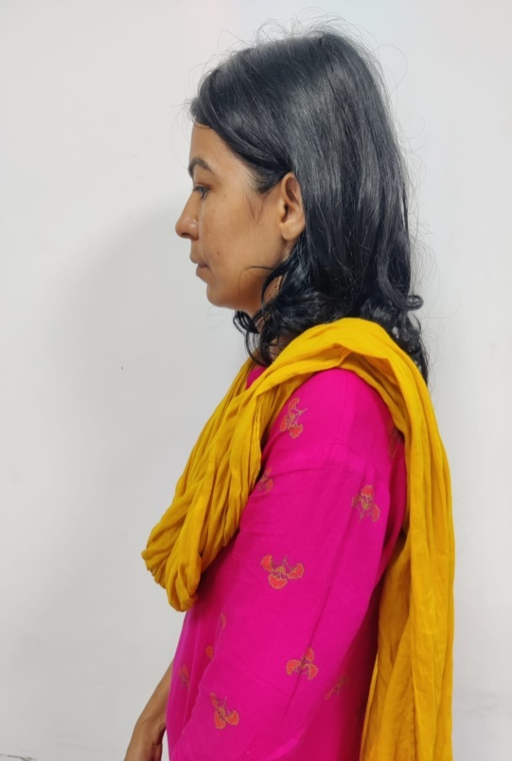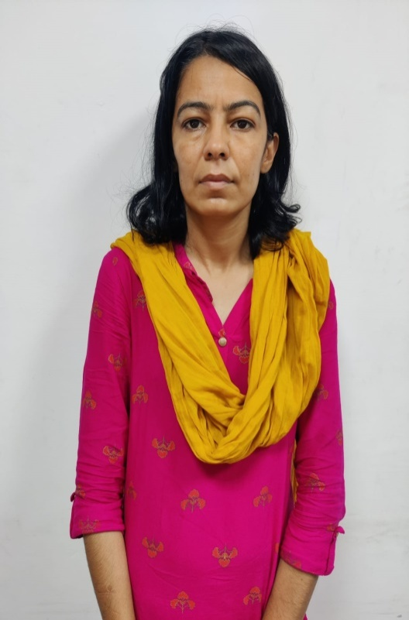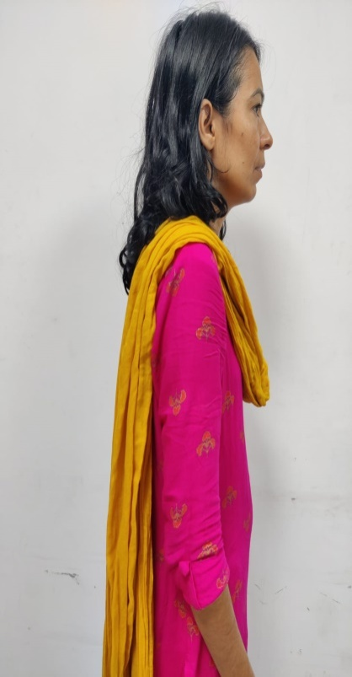

PART-1
Personal details
Name | Anurag @ AnuradhaChoudhary @ Lady Don @ Madam Minj @ Revolver Rani
Code Name | Mom, Didi, Bua
Parentage | ShRamdevMahala
Date of Birth | 21.10.1984
Age | 37 years
Social Status | Criminal/Gangster
E-Mail/I.D.
Facebook or other / I.D.
Nationality | Indian
Marital Status | Divorce from Felix Deepak Minj, Ex Girlfriend of Slain Gangster Anand Pal Singh then got associated with Sandeep @ Kala Jathedi through Vicky (Brother of Anand Pal Singh)  Confessed to get married with Kala Jathedi in Haridwar in November 2020
Personal Documents i.e Passport Number / details of any Photo I.D. | Original Aadhar Card, PAN Card and DL are seized at either Sikar Court or PS Sikar, Rajasthan.
Descriptive Roll | Height |  |  | 164 Cm
Descriptive Roll | Complexion |  |  | Wheatish
Descriptive Roll | Face |  |  | Long
Descriptive Roll | Eyes |  |  | Black
Descriptive Roll | Hair |  |  | Black and Grey (25%), keeps hair upto shoulders
Descriptive Roll | Head |  |  | Normal
Descriptive Roll | Moustache |  |  | N. A.
Descriptive Roll | Built |  |  | Thin
Descriptive Roll | Dress Wearing |  |  | Lower T-shirt at Home, Jeans T-Shirt outside, Shorts and Kurtioftenly.
Descriptive Roll | Spectacles |  |  | Uses on Laptop and Mobile Phone
Mark of Identification | Surgical mark on Right upper armand Mole on Right side of cheek.
Place of Birth | SantogbaDurlabhJi Hospital, Jaipur, Rajsthan.
Present Address | B-107, Raghunath Residency Haridwar, Bahadarabad, Haridwar, Uttrakhand, Pin Code- 249403
Permanent Address | Opposite Modi School, Town and PS Laxmangarh,DisttSikar, Rajasthan, Pin Code – 332311
Religion | Hindu.
Caste/Tribe/Sect | Jat
Occupation | Crime
Educational Qualification | - Upto 8th Class- S. K. Deoda School, Fatehpur, Sikar, Rajasthan (around 1994)  - 9thand 10th Class from VPS School, Police Line, Sikar, Rajasthan (1995-1997, took 2 yrs for 9th class, due to illness) (Hostler for last two years)  - 11thto 12th (With Bio)from Birla School Pilani Rajasthan in the year of (1997-1999) (Hostler)  - Again took admission in VPS School, Police Line, Sikar, for 12th with Maths in 1999, but left school after 4 months  - BCA from Shekhawati College, Sikar (Affiliated to GJU, Hissar) in Regular Mode completed in (2000-2003)  - 12th (With Maths) from Harward School, Greater Noida in 2003  - Got admitted in Bachelor of Engineering at Bits Pilani (2004-2008) in Computer Science (Hostler)  - MBA from Harward Institute of Management, Alpha, Knowledge Park, Greater Noida in (2004-2008) in Regular Mode (Finance + Marketing, HR), stayed at a PG and for some time at Bua’s Home in Greater Noida.  - She applied for M. Phil at Global University, Manipur in 2008, incomplete  - LLB from SK College, Sikar (Affiliated to Rajasthan University, Jaipur) in 2012 (approx)
Residential Address during his/her studies | - Upto 8th at Home,  - Thereafter Hostel,  - Only during BCA at Home
Details of close friends during studies | Not disclosed
Habits | Watching Movies (Comedy, Suspense and Thriller), Reading Books, Learning and using latest Electronic Gadgets
Telephone nos. Held | 7891750780 (Old number)
Arrested By | SI Preeti, CI/Special Cell/NFC/New Delhi
Police Station | Counter Intelligence, Special Cell, New Friends Colony, New Delhi
Place of Arrest | AmanatDhaba, Yamunanagar – Saharanpur Road, Near Sarvasa Road, Saharanpur, Uttar Pradesh.
Circumstances of Arrest | After recovery of illegal -  weapon, she was arrested in case FIR no. 163/2021, U/s 25/29 Arms Act, PS Special Cell, Delhi
Case registered FIR No. Etc | Case FIR No. 163/2021, U/s 25/29 Arms Act, PS Special Cell, Delhi
Action Taken
Source Country ( In case of recovery of Explosives/ Arms/Ammunition or FICN | Not established yet
Route of Smuggling | Not applicable
Name & Addresses of Carrier (s) | Not applicable
Intended recipients (s) Name and Addresses | Nil
Modus Operandi | Kidnapping, Threat, Attempt to Murder, Cheating, Robbery, Arms
Repayment system | Cash
Visit to India Details,( In case of Foreigners) | Not applicable
Previous involvements- | FIR No. & U/s |  | 47/2015, U/s 365/364A/342/395/120B IPC & 25/27 Arms Act
Previous involvements- | Police Station |  | MadanGanj,KishanGarh, Rajasthan
Previous involvements- | Status of case |  | Under trial
Previous involvements- | Status of Accused |  | Bailed by Jaipur High Court, Rajasthan
Previous involvements- | FIR No. & U/s |  | 19/2014, U/s 19/54 Excise Act
Previous involvements- | Police Station |  | Not clear in ICJS Report
Previous involvements- | Status of case |  | Under trial
Previous involvements- | Status of Accused |  | Bailed by Court
Previous involvements- | FIR No. & U/s |  | 162/2018, U/s 143/195/365/323/342 IPC
Previous involvements- | Police Station |  | Ladnun, DisttNagaur, Rajasthan
Previous involvements- | Status of case |  | Under trial
Previous involvements- | Status of Accused |  | Bailed by Jodhpur High Court, Rajasthan
Previous involvements- | FIR No. & U/s |  | 105/2014, U/s 19/54Excise Act
Previous involvements- | Police Station |  | Deedwana, DisttNagaur, Rajasthan
Previous involvements- | Status of case |  | Under trial
Previous involvements- | Status of Accused |  | Bail by ACJM court
Previous involvements- | FIR No. & U/s |  | 245/2014, U/s 364/365/364K/368/346/344/341/342/323/324/307/143/379/420/468/471/120B IPC
Previous involvements- | Police Station |  | Deedwana, DisttNagaur, Rajasthan
Previous involvements- | Status of case |  | Under Trial
Previous involvements- | Status of Accused |  | Bail by Jodhpur High Court
Previous involvements- | FIR No. & U/s |  | 616/2014, 618/2014, 619/2014 U/s 138 NIA
Previous involvements- | Police Station |  | Sikar ACJM Court
Previous involvements- | Status of case |  | Under Trial
Previous involvements- | Status of Accused |  | Arrest not required
Previous involvements- | FIR No. & U/s |  | 19/2016, U/s 42 Prison Act (Recovered from Prison)
Previous involvements- | Police Station |  | LalKothi, Distt Jaipur, Rajasthan
Previous involvements- | Status of case |  | Case finished by court order
Previous involvements- | Status of Accused |  | Conclusion as Conviction, that has been completed during custody
Previous involvements- | FIR No. & U/s |  | 279/2015, U/s 138 NI Act
Previous involvements- | Police Station |  | Kotwali, DisttSikar, Rajasthan
Previous involvements- | Status of case |  | Not known
Previous involvements- | Status of Accused |  | Arrest not required
Previous involvements- | FIR No. & U/s |  | 246/2014, U/s 3/25 Arms Act
Previous involvements- | Police Station |  | Deedwana, DisttNagaur, Rajasthan
Previous involvements- | Status of case |  | Under Trial as per ICJS,  Court Verdicted as 2 yrs conviction, but she plead a stay.  The punishment period has already been completed.
Previous involvements- | Status of Accused |  | Bail by ACJM Court
 | FIR No. & U/s |  | 130/2015 U/S 138 NI Act
 | Police Station |  | Sikar Court
 | Status of case |  | Under Trial
 | Status of Accused |  | Arrest not required
 | FIR No. & U/s |  | 320/2015 U/S 419/420/467/468/471/120B (Fake sim card used in VinodSarraf Case)
 | Police Station |  | Kotwali, DisttSikar, Rajasthan
 | Status of case |  | Under Trial
 | Status of Accused |  | Bail by ADJ, Sikar Court
 | FIR No. & U/s |  | 278/2015 U/S 280/2015 U/S 138 NI Act
 | Police Station |  | Kotwali, Sikar, Rajasthan
 | Status of case |  | Under Trial
 | Status of Accused |  | Arrest not required
 | FIR No. & U/s |  | 191/2015 U/S 143/364A/342/107/216/120B IPC
 | Police Station |  | Kotwali, DisttSikar, Rajasthan,
 | Status of case |  | Under Trial
 | Status of Accused |  | Bail by Jaipur High Court
 | FIR No. & U/s |  | 203/2020 U/S 384/452/506/120 IPC
 | Police Station |  | PS Kuchaman City, DisttNagaur, Rajasthan
 | Status of case |  | Pending Investigation
 | Status of Accused |  | Yet to be arrested
Network Details | Ex-Member and Coordinator ofAnand Pal Singh Gang,  Active member ofSandeepJatehdi @ Kala
Occupation before joining Crime | Stockbroker
Details of bank Accounts | Not available
Details of Credit Card | Not available
Details of Aadhaar Card | Not Available
Name of agency by which these documents are prepared ( D/L Aadhaar etc.) | Not Available
Economic Status | Normal
Main Financer | Money used to be arranged and supplied by her following kingpins through their contacts.  Kala Jathedi  Lawrence Bishnoi  Besides, she had taken 3 plots in Laxmangarh, Ajmer, Jaipur.
Country Visited | Period | Kathmandu in 2016
Country Visited | Purpose | For trip with her son.
Details of Hide outs and harbourer | Not disclosed
Sympathizer /links with politician, Lawyers, Intellectual, Socio religious organizations
Details of Code name | Sandeep @ Kala Jatehdi Group
E mail/FB Ids
Phone Numbers | 8059531253 (Old number)
Expertise in criminal act (Driving skill, Explosion expert, organizer, resourceful, firing skill etc.) | Expert in short range and long range firing, driving four wheeler.
Details if undergone with military training | Nil

PART-II
Family Member
Relation | Father
Name & age | Sh. Ramdev Singh, age 70 years (approx)
Parentage | Lt. Sh. TikuramMahla
Address | Opposite Modi School, Laxmangarh, Sikar, Rajasthan, Pin Code – 332311
E Mail/FB ID | Nil
Occupation | Retd. as Assistant Executive Engineer, from PWD Rajasthan
Contact No.

Relation | Mother
Name & age | Smt. VimlaMahla age 62 yrs (approx)
Parentage | W/oSh. Ramdev Singh
Address | Opposite Modi School, Laxmangarh, Sikar, Rajasthan, Pin Code – 332311
E Mail/FB ID | Nil
Occupation | Home maker
Contact No.
Relation | Brother
Name & age | Manvender @ Manish, 33Yrs
Parentage | Sh. Ramdev Singh
Address | Opposite Modi School, Laxmangarh, Sikar, Rajasthan, Pin Code – 332311
E Mail/FB ID | Nil
Occupation | Property Dealing at Laxmangarh, Sikar, Rajasthan
Phone No.
Relation | Sister
Name & age | Pooja age 26 yrs
Parentage | D/o Ramdev Singh
Address | Opposite Modi School, Laxmangarh, Sikar, Rajasthan, Pin Code – 332311
E Mail/FB ID | Nil
Occupation | MBA, Student (Unmarried preparing for competitive exams)
Contact No.

Relation | Brother
Name & age | Piyush, 30Yrs
Parentage | Sh. Ramdev Singh
Address | Opposite Modi School, Laxmangarh, Sikar, Rajasthan, Pin Code – 332311
E Mail/FB ID | Nil
Occupation | Agriculture
Friends/Associates
Nationality | Indian
Name & age | Sandeep @ Kala Jathedi
Parentage
Address | Jathedi, Sonipat, Haryana
E Mail/FB ID
Occupation | Gangster
Contact No.
Description | Assosiate

PART –III
Associates/Groups and Gangster
- Sandeep @ Kala Jatehdi gang leader

Anti Gang:- RajuTheth Gang from Sikar,
Nephews (Bhanje) Pramod and Inder Chand of JeevanGodara

Places and Location :-Uttrakhand and Rajasthan, MP, Bihar.

PART – IV
Points for follow–up:Anurag @ AnuradhaChoudharywas born on 21.10.1984 at the posting place of herfather i.e. Jaipur, Rajasthan. Her father is a retired personnel as Assistant Executive Engineer. Her mother is a house wife. She passed her 12th class from Sikar. She has two younger brothers and one younger sister (All are unmarried). Herbrother Manvendra is a property dealer, younger brother Puneet looks after agriculture lands. Her younger sister is an MBA and right now preparing for bank exams.
In 2006, she met with Felix Deepak Minj, who was a lecturer at Shekhawati College, Sikar. Over the time they got close and got married in May, 2007.
After completing MBA in 2008, she started her stock broker business with the name Apex Capital in 2009, after taking sub-broker ship from Angel broking in partnership with a banker namely Satish Chandra Dulhad, who was further funded by some political persons of Rajasthan. Anuradha also came in contact with those persons in the end of 2009. Things went smoothly for one and half year almost. In the end of 2010,Satish Chandra did fraud with her, that came in notice of Anuradha in the mid of 2011. Then she met with those funding political persons in person for numerous times. She did some money laundering activities in 2010 for those political persons that were never reported by anyone. Due to disputes she left that business in 2012 and this business was shut down. Its investment was approximately 2-3 crores. In 2012, her husband started to live separately. There were disputes between the two due to business partners of Anuradha. She divorced from her husband in 2013.
In 2013, She came in contact with slain gangster BalbeerBanuda R/o Banuda, Sikar, Rajasthanfor taking her plot back, for which Satish Chandra has got some signatures of her during business partnership. BalbeerBanuda was a dreduous criminal and he was in SikarPrison for some offence. They contacted over telephonically through Kuldeep @ KD @ Doctor. BalbeerBanudaoffered her to join their gang and also offered her a partnership in the gang. But she denied. Later in year 2013-14, a person namely Kuldeep @ KD @ Doctor(Gang member of slain gangster Anand Pal Singh)informed her that Anand Pal Singh want to meet her. Thereafter, she met Anand Pal Singh in Bharatpur Prison for the first time. Thereafter, this plot issue was resolved in favour of AnuradhaChoudhary in 2015.
In 2014 Anand Pal Singh asked her to get bail of Robber Shiv Datt Thakur (Passed away in accident), who was in Prisonin Robbery, murder etc. As Anuradha was also finding someone’s support, she immediately agreed to help him.
In 2013-15, many cases (approx. 10-15) registered against AnuradhaChoudhary in Negotiable Instrument Act, due to check bouncing, by that business partner Satish Chandra Dulhad.
After release of Shiv Datt Thakur, she did her first kidnapping of BookyBadri Narayan Modi R/o Sujangarh, DisttChuru, Rajasthan for ransom on the command of Anand Pal Singh. This crime was committed in association with PratapPanduRai R/O PanduRai, DisttChuru, Rajasthan and other associates of Anand Pal Singh.
In this regard a case (First case) of kidnapping was registered at PS Nechwa, DisttSikar in 2014 against her. A case (2nd case and 1st arrest) in Excise and Arms Act was registered against her at PS Deedwana, Nagaur, Rajasthan when she was at Deedwana Court along with Sonu (Brother of Shiv Datt Thakur) for producing an abducted witness MasterMihip R/o Ladnun, Rajasthan in Khairaj Murder case. Both of them got arrested due to carrying an illegal weapon and scorpio car without number plate. Both of them were released on the very next day. But AnuradhaChoudhary was wanted in previous kidnapping case, so she was taken on production warrant by PS Nechwa, DisttSikar, Rajasthan. She was in Prison for almost 8 months (2014-2015). Then she was released on bail in 2015, which was supported by Anand Pal Singh.
In 2015, she got released from the Prison and thereafter she met with Anand Pal Singh At Ajmer Prison. Anand Pal Singh directed her to kidnap Inder Chand Godara (Brother of JeevanGodara), who was a witness against Anand Pal Singh, in a murder case. Anand Pal Singh had murdered maternal uncle (Mama) of Inder Pal Godara and pramod(Brother of Inder Pal) was complainant/witness of this case. Anuraddha had a meeting with Pramod at AdvNarenderaOjha’s house in Dedwana (Nagaur). This Kidnapping was asked by PramodGodara (Brother of Inder Pal). She completed the given task and kept Inder Pal Singh at various places in Rajasthan and Pune for 10-12 days. This task was completed in association withKuldeep, Guljari, Hanuman Singh, Gattu Singh (Cousin of Anand Pal Singh). In this regard a kidnapping case was registered byInder Pal Singh at PS Deedwana, RJ against all above mentioned names and other associates. In the end of 2015, she was arrested in this case by Rajasthan Police.
She came back to Rajasthan after parting way with other associates and Inder Pal Singh. Further after 19 days in 2015 end,Anand Pal singh asked her to kidnap two property dealers (partners) namely Jitender Kothari and Bhandari of Kishangarh, Distt Ajmer, RJ for ransom. She completed the given task and another kidnapping case was registered against her at PS Kishangarh, Rajasthan. This kidnapping was done in association with KD @ Kuldeep, Gattu Singh, JituCharan, BalveerNimod and Guljari. The victims were kept at Hathos, Near Jaipur. After one day they were released as the ransom money has been delivered. In this regard a case of kidnapping was registered at PS Kishangarh, Rajasthan. In which she was arrested later on.
Further after 18 days, she kidnapped a jeweler (Sarrafa merchant) namely VinodSarraffrom Sikar in association with Kuldeep, Manish Jaat, VikramRathore etc. for ransom on herself will. He was kept for one and half day at Neemkathana, Rajasthan. He was left free as he was not the required person. He also registered a case against AnuradhaChoudhary at PS Sikar, Rajasthan in the year 2015.
In the end of 2015, when she called her associate Manish R/o Rajasthan to meet herself, then he was under trap Rajasthan SOG (Special Operation Group). Then they were arrested from Bhakrota Highway, Jaipur for being wanted in all above mentioned cases and it was the third arrest of Ms. AnuradhaChoudhary. She was in Prison for almost 3 years. Initially she was in Ajmer Prison for 4-5 months, later on sent to Jaipur Prison. She was released in March, 2018.
Meanwhile on June 24, 2017 gangster Anand Pal Singh was shot dead in an encounter between Rajasthan Police and Anand Pal Singh at Village Malasar, DisttChuru, Rajasthan. At this time gangster Anand Pal Singh was on ferari (run) from Prison (ran from high security during production before court) since Sept 03, 2015.After his death, the whole group insisted AnuradhaChoudhary to handle the group of Anand Pal Singh. (Earlier she has accepted that she ran the group on her own for some time, now she is saying that the group was divided into parts and things were handled by Chinu @ Charanjeet D/o Anandpal, Ishwar, Vicky Singh @ Bhupender Pal Singh(brother), ShubhashBaral (active member of group), she made herself in passive mode stating mentally unfit herself). In the start of 2018 she got normal.
Meanwhile she also ran some books (satta) from inside the Prison.
Further she was at her paternal home for almost one and half months. And arrested for the fourth time in connection to a kidnapping of Mihip Patel case, that was a 6 years old incident (i.e. in 2014). Furthermore, when she wasarrested for previous time, a fake sim card in connection with VinodSarraf case has also been recovered from her. This matter was under enquiry for past 3 years. But at this point of time, as her enquiry has been completed, so that case has also been added on her. After a month, PASA (type of MACOCA in Rajasthan) was also applied on her. But it was also removed due to some undisclosed reasons. She was released from Prison almost after 14 months in August 2019.
After release, she stayed at her home for almost one year i.e. upto Aug 27, 2020. On Aug 23, 2020 she talked to Bookie Sunil over whatsapp video call regarding making her books clear through a person namely Bahadur. Then another bookie namely Anil Singh called AnuradhaChoudharyfor confirmation whether AnuradhaChoudhary called Sunil and asked clearance for her partnership, for which AnuradhaChoudhary replied affirmatively. The response from Anil Singh was “Theekhai”. After 2 days, a threat case registered against her at PS Kuchaman, Rajasthan. So she fled away from her home. She carried cash around Rs. 4,50,000, that was given by a lender of business time.
She stayed in Bikaner for around a month then moved to Udaipur for around 10 days. Then she moved to Jaisalmer and stayed there around a month. In these two months she stayed in hotels. Then she travelled to Indore, MP via sleeper bus for three days.
Later on in Nov, 2020, she met with Kala Jathedi at Indore, MP on instructions of Vicky Singh (brother of slain gangster Anand Pal Singh). They got married in a temple and stayed like husband-wife in a rented accommodation near Devas, Indore, MP. They had i20 car of white color. They stayed for 4 months in Indore. Meanwhile in January end or February start she asked Prakash for firing on Sunil at his residence, which was done but nobody was harmed. So another case of firing was registered against her at PS Kuchaman, DisttNagaur, Rajasthan. In this connection Prakash, Mool Singh, Laxman etc. a total of five persons were arrested.
In March, 2021, they left Indore, travelled via bus and went to Bihar. They stayed in a rented accommodationat RajniChowk,Vivekanand Colony,Poornia, Bihar. On June 30, 2021 they left Bihar and then went to Lucknow and met with Lota.
Further they travelled to Shirdi, Mumbai, in Maharashtra, Tirupati, Mathura, Agra etc. and lastly settled at Raghunath Residency, Bahradpur, Haridwar, Uttrakhand in the 2ndweek of July, 2021.
On 30.07.2021 along with Kala Jathedi, she was travelling to UPin possession of illegal weapon and there apprehended at AmanatDhaba, Near Sarvasa Toll, Sarvasa on Yamuna Nagar to Saharanpur Highway by team of Counter Intelligence : Special Cell, Delhi and got arrested vide FIR No. 163/21 u/s 25/29/54/59 Arms Act PS Special Cell.

